A Spring Visit to Bear Spring Camps: Belgrade, Maine

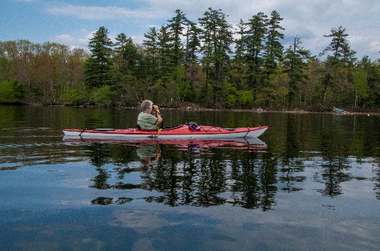

Spring brings many changes, but one thing is constant: a trip north to begin a season of kayaking and outdoors activities. We spent a week at the Bear Spring Camps enjoying tranquility, excellent food and cabin care, and seven days of sun, calm winds, heavy winds, camp fires, great kayaking runs and entertaining wildlife.

And for the photos, click on the [Bear Springs - May, 2018](https://photos.app.goo.gl/3ptw2xTudcTT5Uet8).